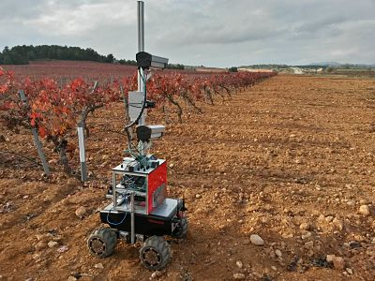

**AUTOMATION IN AGRICULTURE**

**PRESENTED BY**

**Ayush Kesarwani**

**Rajat Kumar**

**Akshita Gupta**

**AUTOMATION**

* The work is done by robot without any man power.
* Automation is used in all fields eg ; automobiles , manufacturing fields.
* Automation is a illumination of human afford from the working field.
* Recently automation is used in agriculture.
* Major work in agriculture are done with the help of automation.
* Pesticide spraying , dropping the seeds , ploughing , providing water to crop.



**AGRICULTURE AUTOMATION**

* Agriculture robot or agribot deployed for agriculture purposes.
* Fruits picking robots , driverless tractor/sprayer, and sheep shearing robots.
* Pruning , weeding , spraying and monitors of orchids.
* Livestock application , Automatic milking , washing.
* Less needs for labour work.



**NEEDS OF AUTOMATION**

* Automation in agriculture is very necessary because of firstly by the year 2042, the world population is projected to increase to 9 billion souls.
* Secondly with tradition method of agriculture some drawbacks like wastage of seed, improper spraying of pesticide on crop so soil standard get degrades also food become harmful to human body.
* . In order to overcome all the above drawbacks of tradition agriculture and to become the agriculture field modern , hi-tech and fastest growing





CONTD....

* Lack of man power.
* For maintaining uniformity.
* Mechanization and automation in agricultural fields improves the productivity.
* Water irrigation methods like trip ,springler, by automation reduces the utilization of water.
* By automation processes crop calendar is maintained.



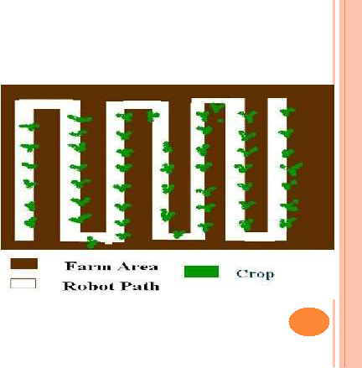**PROGRAM FOR ROBOTS**

* Designing automatic system we provide proper tracking through the white line following robot concept in which the robot distinguishes white and black or dark surface and follows only white track.
* To this concept we are going to implement a white line on a farm where actually we need to work & remaining surface is treated as a black surface due to the brownish color of soil.

**WORKING OF ROBOTS**

* We provide delay to robot at equal distance to do the agriculture work like pesticide spraying, water supplying, plugging, dropping of seed, accurately and automatically.
* The pesticide liquid which is contain by a tank is came through the rubber pipe to the tip of DC motor , at that shaft of motor a fan blade is attach , which revolves at the delay time of robot or on front of crop.
* Due to revolution the liquid get spray on crop.



**FOOD SHORTAGES , BIG BUSINESS**

* The World Bank says we'll need to produce 50% more food by 2050 if the global population continues to rise at its current pace.
* But the effects of climate change could see crop yields falling by more than a quarter.
* So autonomous tractors, ground-based sensors, flying drones and enclosed hydroponic farms could all help farmers produce more food, more sustainably at lower cost.

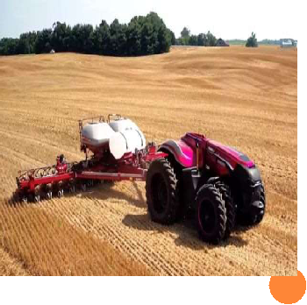

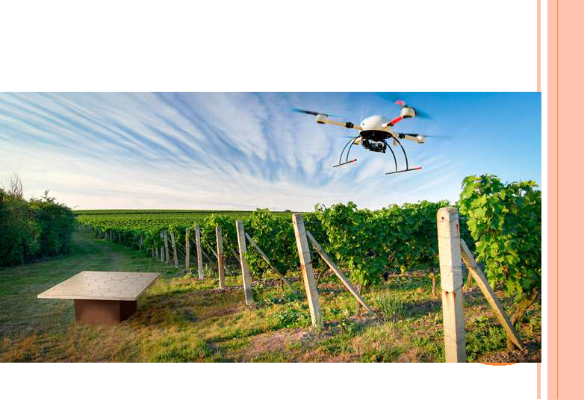**AUTOMATION APPLICATIONS**

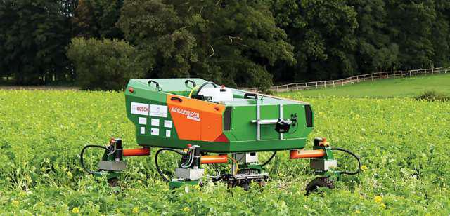

**PRECISION PRUNING**

* But even here automation is encroaching.
* [**Wine makers have used**](http://www.bbc.co.uk/news/business-20200856)[**drones** to inspect their](http://www.bbc.co.uk/news/business-20200856)vineyards for several years, with high-definition cameras and sensors assessing crop and soil health.
* But in France's Burgundy region, a shortage of farm labour has led inventor Christophe Millot to develop a vine-pruning robot called Wall-Ye.

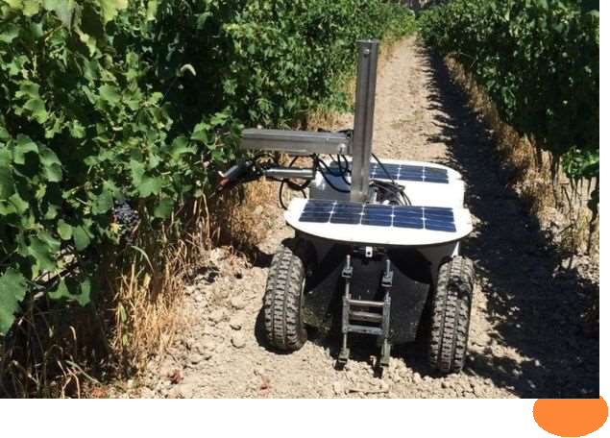



CONTD....

* The machine learns as it goes and can trim the grass around each vine. An onboard solar-powered battery gives 10-12 hours of charge, so with a change of battery, it can work day and night.
* Visual recognition is the biggest challenge, says Mr Millot - knowing where to make the cut. This is actually easier at night, because the robot's lights can illuminate the plant, but not its background.

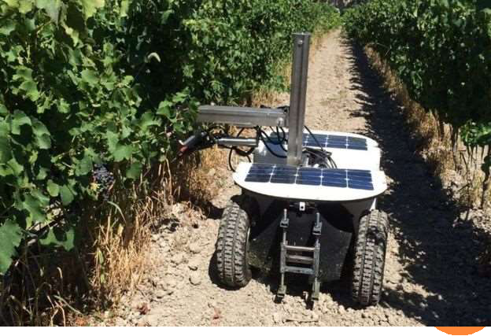

**ROBOT LETTUCE**

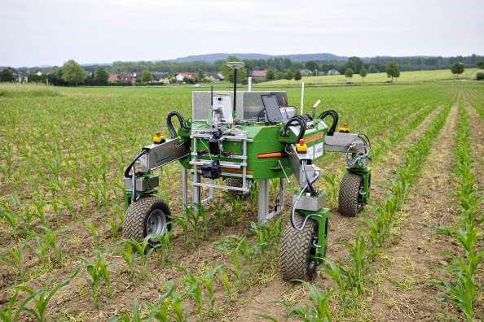

* Japanese firm Spread's automated vegetable factory in Kyoto, due to launch next year, could produce 30,000 lettuces a day.
* It stretches up, instead of across undulating fields, because "in countries like Japan, where land is actually a very scarce resource, it makes more sense to stack your production.





CONTD....

* After seeding will be done by machines - watering, trimming, harvesting - on shelves stacked from floor to ceiling.
* Automation has reduced labour costs by 50%, says Mr Price. And LED lighting developed specifically for plant cultivation reduces energy costs by 30%. And growing vegetables in vertical farms means you can recycle 98% of the water.

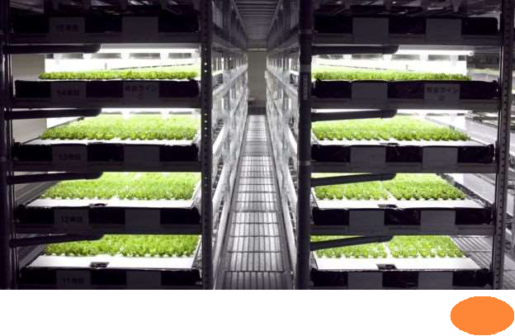

FUTURE TRENDS IN AUTOMATION

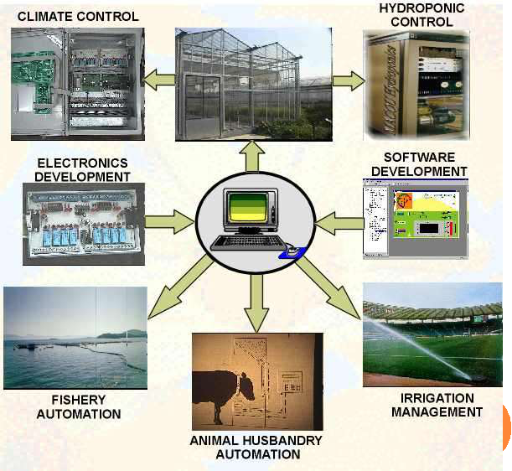

**ADVANTAGES**

* Eco friendly.
* Reduces human effort.
* Improves the productivity.
* Uniformity of work.
* Reduce the production cost.
* Less operating cost.



**DISADVANTAGES**

* High initial cost.
* Requires knowledge about robot for operators.
* Reducing job opportunities.
* High maintenance cost.
* Suitable for farming in large areas.



